Please put in your code for the questions that are applicable.

1. In your own words describe what is a pointer
2. Which of the following in C++ is a pointer
   1. int r, j;
   2. char *options;
   3. float &pathogens;

int menu = 23;

1. Print out the value of menu
2. Print out the address of menu

int *menu_pointer = &menu;

1. Print out the value of menu using menu_pointer.
2. Print out the address of menu using menu_pointer.
3. Print out the value in menu_pointer.
4. Print out the address of menu_pointer.
5. Change the value in menu using menu_pointer.

3. Write an expression to calculate the address of the variable testvar.

4. Define a variable named char_pointer whose data type is a pointer to a char.

5. Create a class with the name of ‘cat’ that contains a pointer to another ‘cat’

6. In your own words tell me why a pointer is important.

7. Write a function that increments the parameter by 2 permanently and returns nothing (void). After calling said function print out the variable you passed to the function in main and show that the function changed the value of the variable.

8. 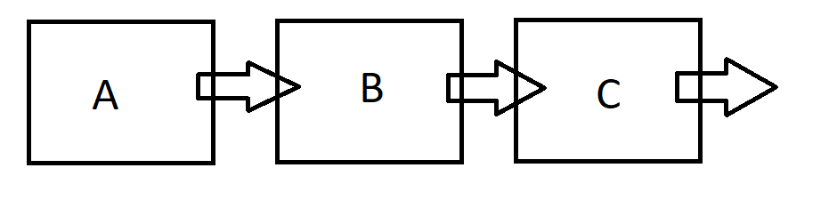  
  
 What does A point to?

What does B point to?

What does C point to?